ITIL 4 Framework Summary:

We come a long way throughout this course. And in this lesson I want to put it all together. We started out talking about our four dimensions of service management, which includes organizations and people, information technology, partners and suppliers, and the value stream and processes.

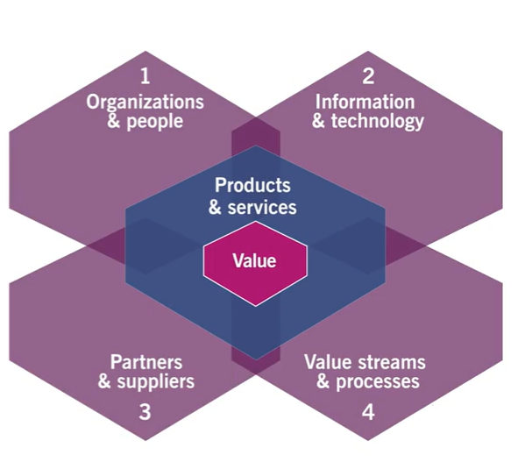

Then we talked about the ITIL service value system. This included our opportunity and demands as our input, and those are shaped by our service value chain, our governance, our practices, our guiding principles and our continual improvement and out the other side, we got value.

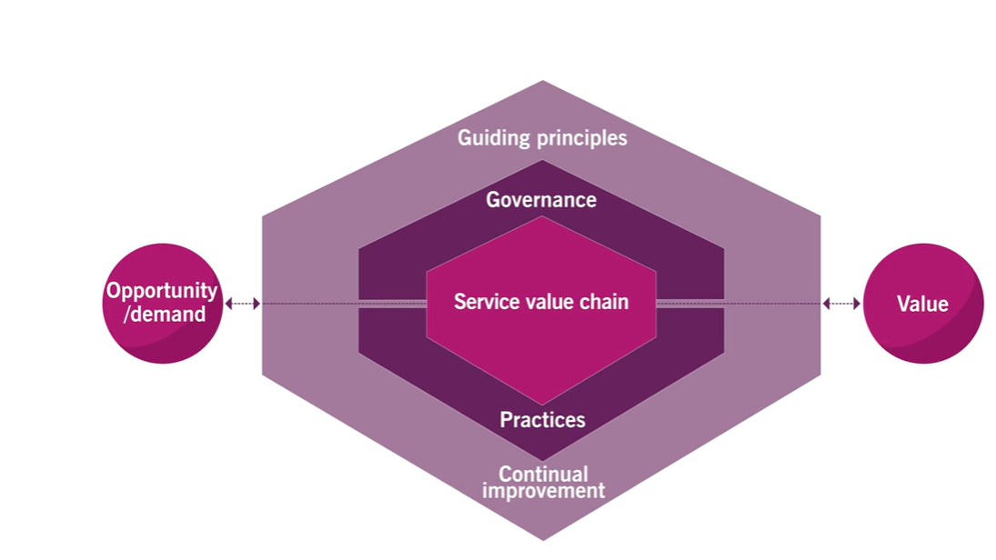

Now we also dug into the service value chain itself as part of the source value system. We explored the different parts of it like engage, plan, improve, design and transition, obtain and build, delivering support and our products and services. And then we spent the last three sections in this course, looking at the 34 different practices across ITIL four.

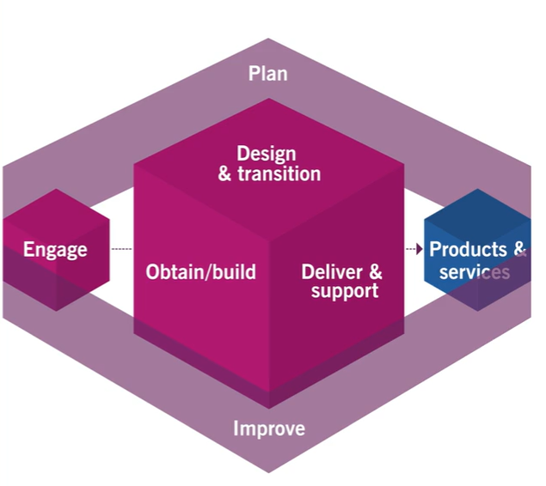

But now it's time for us to put it all together. So let's walk through a real world scenario with an incident that needs to be resolved. And so everything we talked about so far will be integrated together to create the desired value.

Now let's pretend to work for a large logistics company, something like walmart or amazon, and we're part of their IT service management organization within the company. They have a warehouse that uses a Wi Fi network in order to allow the forklift driver to receive instructions on his mobile device that tells him which aisle and which rack the product is that he needs to go pick up.

Unfortunately, the wireless access point that supports the Wi Fi in this area, the warehouse isn't working so well. And so the drivers mobile device can't get the information that he needs. Now, this has a significant impact on our business because whenever that forklift driver can't receive the instructions quickly enough, there's a risk that a tight business deadline might be missed.

After all, some companies like Amazon rely on their super fast shipping as a core function of their business model. Now, while this may seem like a relatively straightforward incident, it can't be resolved simply by following the steps of a predetermined Incident Management procedure instead there's a lot of interconnections among the practices and the activities for this wireless network to get fixed, return to normal operations.

So let's get started with the service value system first. First, we're going to see that we have a demand and in this case, the warehouse manager and the forklift driver discovered the Wi Fi coverage isn't working properly in a certain portion of the warehouse. This means the forklift driver needs to drive back to the manager's office.

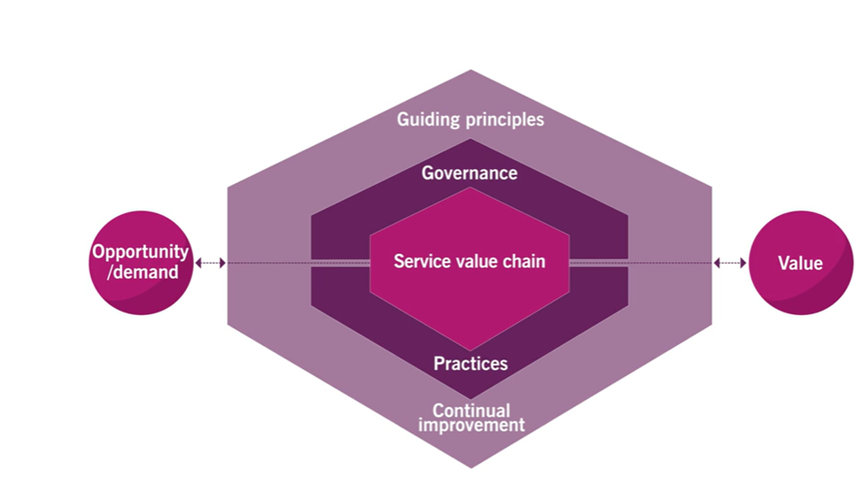

In between each pickup. We can find out the location of his next part within the warehouse. This is causing delays and that could cause delivery deadlines to be missed. This is an incident from this man, we now move to the engaged activity where the warehouse manager is going to call up the service desk. The Service Desk Agent listens to the issue that's being described by the warehouse manager. They log in as an engineer into the management system. And they categorize that incident as a high priority.



Unless the warehouse manager know if they're going to escalate the issue to the technical support team that's responsible for that wireless network. And they provide updates every two hours until that issue is fixed. Now the Service Desk Agent escalation ticket for the wireless network up to the wireless network support team.

These are the folks who have the delivery and support folks in the value chain activity for this wireless network. This allows the Service Desk Agent to provide the information to the network support engineer and the diagnosis and analysis of the incidents that begin by the engineer.

Next, the network support engineer identifies that the wireless access point has failed and she decides to replace it with a spare from the existing spare parts inventory. This action alone is going to involve several practices. First, we have the IT asset management practice so that she can update the serial number in the configuration item database.

Then she goes through the service configuration management practice because she needs to configure this device based on the approved baseline and install it. She's also going to go through the change control practices since she's going to install a new piece of equipment into the network. And of course, she's gonna go through incident management because she's working on resolving an incident.

Let's assume that the replacement of this wireless access point is considered a standard change. So no additional approvals are needed. Because a no change. No one will have to go through and get approval for the change management process or escalate that issue as an emergency change. Either way, all of this would have COVID in the change control practice than right.

Finally, our network engineer replaces the access point verifies it's working and she updates the Incident Management System, as a center says and tells her that she believes the incident has been resolved.

Now that the engineer has fixed the incident, she sits back and thinks about what happened and she thinks about any possible ways that she could have fixed this more efficiently. If she thinks of any. She might add those to the continuous improvement register as suggestions for future improvements. Thus this has become part of continual improvement practice in the in productivity.

Now the service does need to on the other hand goes back to the Engage activity by contacting the warehouse manager and she tells him that the wireless network should be working again. She asked the manager to verify that the forklift drivers mobile phone is working again and gets a confirmation of this and when she does, she can then close that phone.

Now when we look at the final block on the service value system that's valid. The value is being co created by ensuring the wireless coverage is restored and the Florida driver can now perform his job more efficiently once again, by using that mobile device to identify the location of the project you need to pick up in. About an hour later that warehouse manager might receive a brief email asking for a user satisfaction survey. This might ask for his feedback on the incident and its resolution this will become a comedian right? Well, if you filled out the survey, we can then take that and based on the feedback received, we can identify trends and patterns based on satisfaction scores in the users comments.

This would fall under our improve area. And we're going to be determining if our incident management system and our processes are working effectively. So that was a lot. As you can see all of this ties together and we enter in different activities and different practices all throughout this single incident and a single resolution.

It isn't a simply linear process. But instead we're bouncing, engage to deliver and support back to engage over to improve and many of the practices several times during this quick example. Remember, identifying and understanding all of these interconnections is the key to establishing and promoting good service management.

So when you're looking at one of the processes, or one of your workflows, need to consider all of these things as you're laying it out. so you can make sure you're doing it the most efficient and effective way possible.